[](http://www.google.be/url?sa=i&rct=j&q=coca%20cola%20logo&source=images&cd=&cad=rja&docid=zLKrONOtNJyBuM&tbnid=ejihgGeGfSvAFM:&ved=0CAUQjRw&url=http://www.promotionalitemsbuzz.com/tag/cocacola-logo/&ei=phYCUoSoNIjgOoPlgNgI&bvm=bv.50310824,d.ZWU&psig=AFQjCNHLjQxfZoMtLhz56GrQXCOm1TXqYg&ust=1375954971622392)

*2014*

***27 – 29 december***

***KORTRIJK (BELGIUM)***



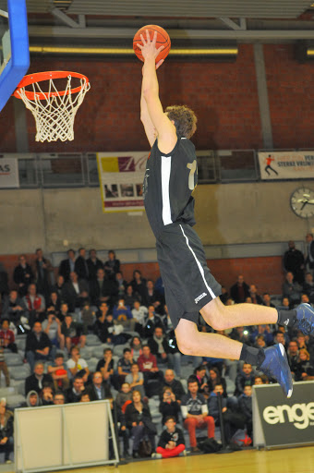



***INVITATION***

***9th International Coca Cola Christmas Tournament, in Kortrijk (Belgium)***

*We kindly invite you at the 9th Coca Cola international Youth X-Mas Tournament, the highest ranked youth basketball tournament in Western Europe. Our event aims at gathering some of the best international youth basketball teams in Kortrijk, for a top level competition. We focus on bringing quality both on the field and around the field. Over the last years, we hosted teams from* ***22 different countries. In the 2014, we had for the first time a team from Canada competing in the tournament, amongst a total of 104 participating teams.*** *Teams are always happy to come back to Kortrijk !*

*The overall principle of the tournament remains unchanged, after the successful edition in 2013. Thanks to the experience of the past years, and the feedback of the participants, we will try to organize a splendid edition in 2014. The main change this year:*

* ***One age group will be added: Women Under 16.***



***Dates:***

***December 27th, 28th and 29th 2014***

***Categories:***

* ***Men Under 19 Invitational (year of birth 1996 or later) \****
* ***Men Under 19 Open (year of birth 1996 or later)***
* ***Women Under 19 Open (year of birth 1996 or later)***
* ***Men Under 16 Open (year of birth 1999 or later)***
* ***Women Under 16 Invitational (year of birth 1999 or later) \****
* ***Women Under 16 Open (year of birth 1999 or later)***
* ***Mixed Under 14 Open (year of birth 2001 or later)***

***\*: for this competition, a separate invitation is forwarded***

***Number of teams:***

***In each age group, the number of teams will be limited   
to maximum 16 teams.***

***Number of games:***

***SIX games for each team (except Invitational tournaments).***

**Visit our website: www.x-mastournament.be**

***Tournament information***

* *For granting a high competition level, participation is only open for teams playing on the highest competition level in their respective countries.*
* ***Start of the tournament:*** *Saturday December 27th at 9Hr.*
* ***End of tournament****: Monday December 29th at 18.30 Hr. All teams will however receive their rewards immediately after their last game. This for allowing those teams who have to travel far to leave earlier.*
* ***Location:*** *Kortrijk, Wevelgem, Deerlijk and Zwevegem (BELGIUM). These places are all located at minor distances from one another.*
* ***Game length:******4 x 10’*** *for the Invitational competitions and for all others* ***4 x 8’*** *(stopped time).*
* ***Prices:*** 
  + 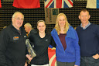***Coach Van Kers****, a living legend of coaching in Belgium will offer the MVP awards for the men’s competitions.*
  + ***An Wauters****, multiple European player of the year will offer the “An Wauters MVP Awards” for the women’s competitions.*
  + *On each site a* ***3 point shooting contest*** *will be organized. The winners will be awarded.*
  + *In MU19, a* ***dunk contest*** *will be organized. The winner will be awarded.*
* ***Referees:*** *All games will be led by 2 or 3 official referees, under FIBA rules. All tournament referees are part of the national and regional talent pool.*
* *Men U19 and WU16 will be split into two categories:* 
  + *An “Invitational” will be organized, with national and club teams belonging to the European top level. These teams will receive a separate invitation. Clubs wishing to participate in this competition can however contact the organizer by mail.*
  + *An "Open" competition with all other Men U19 teams.*
* 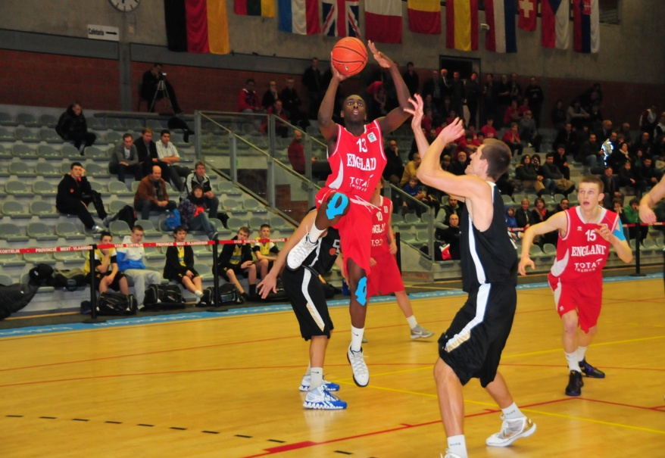***Point of contact for all information****:*

*Peter De Lepeleire*

***Tel****: +32(0)56/64.70.37*

***Mobile****: +32(0)477/24.52.83*

***Mail****:* [*Peter.delepeleire@telenet.be*](mailto:Peter.delepeleire@telenet.be)

***Skype:*** *peter_de_lepeleire*

*[ibis Accor hotels](http://www.ibishotel.com/)****Tournament program***

***December 26th****:*

* *Arrival of teams wishing to stay an additional night in Kortrijk.*

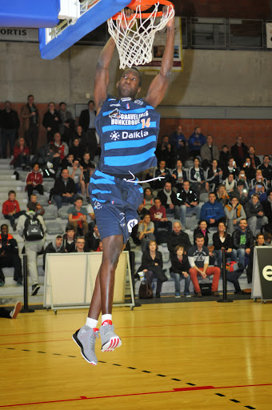

***December 27th:***

* *Arrival of the teams.*
* *Registration at the tournament site.*
* *Registration in the respective hotels.*
* *Opening ceremony.*
* *Two qualifying games for every team.*
* *Tournament for U12 - qualifying games*

***December 28th****:*

* *Two qualifying games for every team.*
* *Evening: three points contest (all categories) and dunk contest (MU18).*
* *Tournament for U12 - final games*
* *Tournament for U10 - qualifying games*

***December 29th****:*

* *Semifinals and finals.*
* *Tournament for U10 - final games*
* *Medal ceremonies.*
* *MVP election.*
* *Shooting competition for local teams.*

**

***With the support of***

***the Flemish Basketball League***

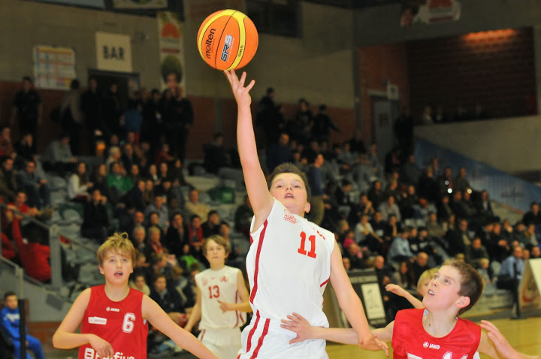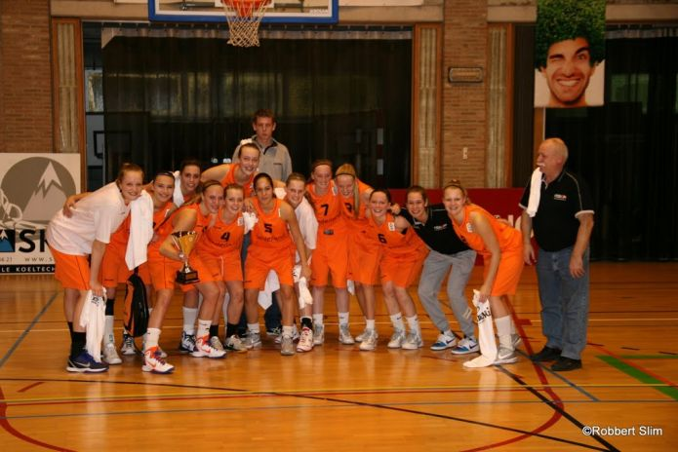

***Past results***

|  |  |  |  |  |  |
| --- | --- | --- | --- | --- | --- |
|  | ***Men U19 Invitational*** | ***Men U19*** | ***Men U16*** | ***Men U14*** | ***Women U19*** |
| ***2006*** |  | 1. *Power Wevelgem (BEL)* 2. *Vaillante Jupille (BEL)* 3. *Pepinster (BEL)* | 1. *Power Wevelgem (BEL)* 2. *Basket Groot Leuven (BEL)* 3. *Sparta Deerlijk (BEL)* |  |  |
| ***2007*** |  | 1. *Antwerp Giants (BEL)* 2. *Power Wevelgem (BEL)* 3. *MG Amsterdam (NED)* | 1. *BC Gistel Ostend (BEL)* 2. *BS Waregem (BEL)* 3. *CEP Fleurus (BEL)* |  |  |
| ***2008*** |  | 1. *BBC Kontich (BEL)* 2. *Bergen op Zoom (NED)* 3. *Power Wevelgem (BEL)* | 1. ***England NT*** 2. *BS Waregem (BEL)* 3. *Harlemlakers (NED)* |  |  |
| ***2009*** |  | 1. *CBiUM Manresa (SPA)* 2. *BS Waregem (BEL)* 3. *Pitzemburg (BEL)* 4. *TMCI Wevelgem (BEL)* 5. *Okapi Aalst (BEL)* | 1. *Flemish selection (BEL)* 2. *Castors Braine (BEL)* 3. *CEP Fleurus (BEL)* 4. *Sparta Bertrange (LUX)* 5. *Falco Gent (BEL)* | 1. *Tornados Kaunas (LIT)* 2. *Kortrijk Sport CB (BEL)* 3. *Bavi Vilvoorde (BEL)* 4. *TMCI Wevelgem (BEL)* 5. *Diremta Kaunas (LIT)* |  |
| ***2010*** |  | 1. ***Norway NT*** 2. ***Belgium NT*** 3. *BCM Gravelines (FRA)* 4. *Berlin Süd (GER)* 5. ***Netherlands NT*** | 1. *Flemish selection (BEL)* 2. *BBA Ludwigsburg (GER)* 3. *Eifeltowers (NED)* 4. *IBBA Berlin (GER)* 5. *Harlemlakers (NED)* | 1. *Flemish selection (BEL)* 2. *Bavi Vilvoorde (BEL)* 3. *Castors Braine (BEL)* 4. *Gentson (BEL)* 5. *BBLZ Giesen (GER)* |  |
| ***2011*** | 1. *Atletas Kaunas (LIT)* 2. *Canarias Basket (SPA)* 3. ***Belgium NT*** 4. ***England NT*** 5. *USK Prague (CZE)* | 1. *BCM Gravelines (FRA)* 2. *Falco Gent (BEL)* 3. *Bavi Vilvoorde (BEL)* 4. *Okapi Aalst (BEL* 5. *Antwerp Giants (BEL)* | 1. *Kortrijk Sport CB (BEL)* 2. *Willibies Antwerp (BEL)* 3. *BBA Ludwigsburg (GER)* 4. *BS Waregem (BEL)* 5. *Castors Braine (BEL)* | 1. *BS Waregem (BEL)* 2. *Sélection Pas de Calais (FRA)* 3. *BBLZ Giessen (GER)* 4. *Nurnberger BC (GER)* 5. *Alba Berlin (GER)* | 1. ***Netherlands NT*** 2. *Bratislava (SVK)* 3. ***Belgium NT*** 4. *Blue Cats Ieper (BEL)* 5. ***England NT*** |
| ***2012*** | 1. *Belgrade Basket (SRB)* 2. ***Hungary NT*** 3. ***Belgium NT*** 4. *Antwerp Giants (BEL)* 5. ***England NT*** | 1. *Okapi Aalst (BEL)* 2. *Kortrijk Sport CB (BEL)* 3. *BS Waregem (BEL)* 4. *Flemish selection (BEL)* 5. *Leuven Bears (BEL)* | 1. ***Netherlands NT*** 2. *Gembo Borgerhout (BEL)* 3. *Flemish selection (BEL)* 4. *Falco Gent (BEL)* 5. *Okapi Aalst (BEL)* | 1. *BBLZ Giessen (GER)* 2. *Okapi Aalst (BEL)* 3. *Kortrijk Sport (BEL)* 4. *Telenet Oostende (BEL)* 5. *Betafence Zwevegem (BEL)* | 1. *ZKK Triglav (SLO)* 2. *BK Bratislava (SVK)* 3. *Grasshoppers (NED)* 4. *Blue Cats Ieper (BEL)* 5. ***England NT*** |
| ***2013*** | 1. *Antwerp Giants (BEL)* 2. *Israel Basket Acad (ISR)* 3. *Flemish Selection (BEL)* 4. *Belgrade Basket (SRB)* 5. *Canarias Basket (SPA)* | 1. *CR AWBB (BEL)* 2. *BBA Ludwigsburg (GER)* 3. *Falco Gent (BEL)* 4. ***LUXEMBURG NT*** 5. *Gembo Borgerhout (BEL)* | 1. *Canarias Basket Aca (SPA)* 2. *Antwerp Giants (BEL)* 3. *BS Waregem (BEL)* 4. *100x100 Olost (SPA)* 5. *Sparta Bertrange (LUX)* | 1. *Kortrijk Sport (BEL)* 2. *Racing Brugge (BEL)* 3. *BS Leiden (NED)* 4. *Antwerp Giants (BEL)* 5. *Maccabi Ramat Gan (ISR)* | 1. *BMS Copenhagen (DAN)* 2. *Flemish Selection (BEL)* 3. *BJBS Riga (LAT)* 4. *Belgrade Basket (SRB)* 5. *BV Den Helder (NED)* |

***NT = National Team***

***Practical issues***

* ***Lodging (more details on our website)***

*One of the strong points of the organisation is the lodging accommodation. All teams will be accommodated in very high level hotels. The provisional list of hotels:*

* ***Altia Hotel*** *in Neuville-en-Ferrain (*[*www.altia-hotel.com*](http://www.altia-hotel.com)*)*
* ***Mercure Hotel*** *in Marcq-en-Baroeul (*[*www.mercure.com*](http://www.mercure.com)*)*
* ***Park hotel*** *in Kortrijk (*[*www.parkhotel.be*](www.parkhotel.be)*)*
* ***Center hotel*** *in Kortrijk (*[*www.centerhotel.be*](www.centerhotel.be)*)*
* ***Ibis hotel*** *in Kortrijk (*[*www.ibishotel.com/nl/hotel-6330-ibis-kortrijk-centrum*](http://www.ibishotel.com/nl/hotel-6330-ibis-kortrijk-centrum)*)*
* ***Focus Hotel*** *in Kortrijk (*[*www.focushotel.be*](http://www.focushotel.be)*)*
* ***Best Western Hotel Alizé*** *in Mouscron (*[*www.hotellize.be*](http://www.hotellize.be)*)*
* ***Best Western Ambassador Hotel*** *in Menen ([www.ambassadorhotel.be](http://www.ambassadorhotel.be))*
* *teams are not obliged to lodge in one of our hotels. Teams can arrange their own accommodation (there are some low cost hotels in the neighbourhood) and take only the tournament meals (see further).*
* *Teams arriving earlier or leaving later can be accommodated additional nights in the same hotels as during the tournament at very favourable prices. The organizer will arrange this.*
* *An unlimited number of friends, family,.... can be accommodated at the same hotels as the team during the tournament. Prices: see below.*
* ***Meals:***
* *Breakfast buffet on December 28th and 29th will be served in the hotel. Every hotel offers a high standard breakfast buffet.*
* *The other tournament meals (5 in total: lunch on December 27th, 28 and 29th, and supper on December 27th and 28th) will be served in the tournament restaurants (at the gyms). This year again, we did a huge effort for improving the quality of the nutrition. Fruit and vegetables will be part of the meals.*
* *It will be possible to order additional meals for teams arriving earlier or staying longer. We can propose several restaurants in Kortrijk that offer meals at very advantageous prices for our participants.*
* 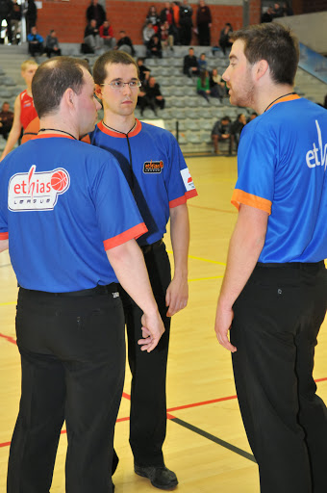***New:*** *On each site, several hot and cold dishes and sweets will be available in the cafeterias, for those people who don’t wish to take the tournament meals.*
* ***Transport****:*
* ***Arrival by car or by bus:*** *Kortrijk can be reached very easily, from all directions, by E17 highway.*
* ***Arrival by train:*** *Kortrijk has a main rail station with good connections to Brussels and Lille (TGV and Eurostar railway station, France).*
* ***Arrival by airplane:*** *nearby airports are Brussels National Airport (Zaventem) and Lille Lesquin. A direct train connection exists between the airports and Kortrijk railway station.*
* *We can arrange airport shuttles for teams arriving in Brussels National Airport, Brussel South (Charleroi) and Lille Lesquin for a cost of* ***150 € per team****.*
* *During the tournament, all gyms can easily be reached by public transport.*
* ***Additional services:***

*Teams needing, for one or another reason, additional services (laundry, medical, cultural, social ...) can contact the organizer. Whenever possible we will assist you.*

* ***Media***
* *X-Mas TV will offer, on our website, from September on, several videos of the tournament preparation. During the tournament, clips will be updated daily.*
* *The most recent information about the tournament is available on the tournament’s web site: (*[*http://www.x-mastournament.be*](http://www.x-mastournament.be)*)*
* *The situation of the registrations will be updated daily. During the tournament, the results will be adapted in real time.*
* ***New****: since 2013, the finals in the main age groups are on livestream !!!*

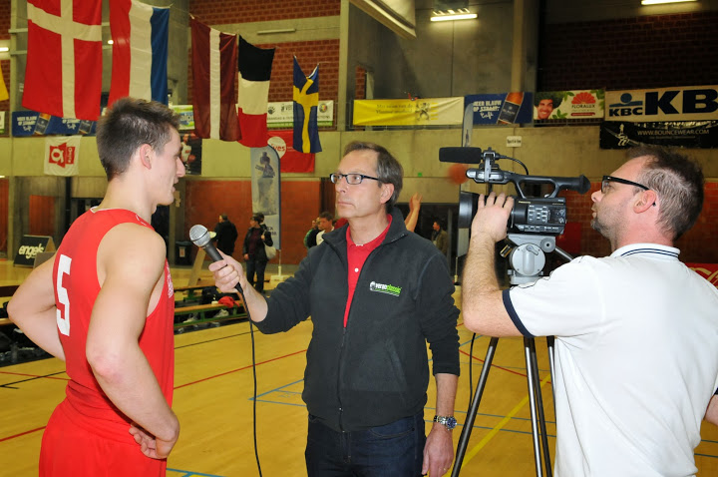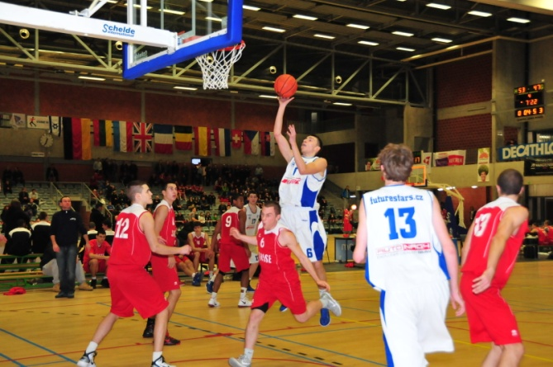

* ***Other activities***
* *During the Christmas period the city of Kortrijk is decorated, illuminated, ice skating is possible and Christmas markets are organized.*
* *Kortrijk is both a historical city AND a very well known shopping city.*
* *In the vicinity of the tournament cities, you can visit other places of historical interest:*
  + *Bruges (30 minutes from Kortrijk by train)*
  + *Gent (20 minutes from Kortrijk by train)*
  + *Ypres (20 minutes from Kortrijk by train)*
  + *Lille (20 minutes from Kortrijk by train)*
  + *Brussels (1 hour from Kortrijk by train)*

*[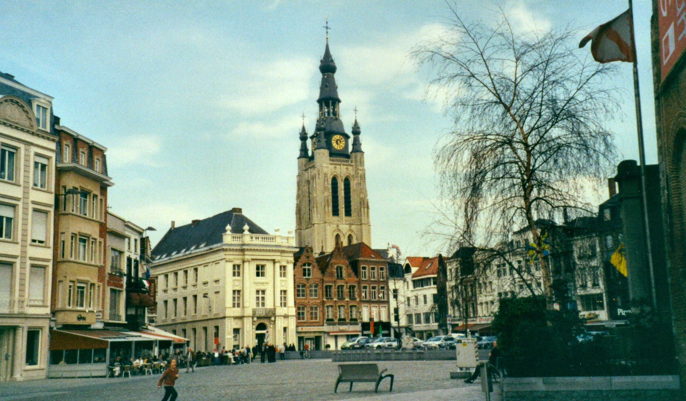](http://www.google.be/url?sa=i&rct=j&q=kortrijk&source=images&cd=&cad=rja&docid=HEQaCaBwqJ8PoM&tbnid=QTMtkVJvs9uMFM:&ved=0CAUQjRw&url=http://commons.wikimedia.org/wiki/File:Kortrijk_aka_Courtrai_in_Belgium_Redvers.jpg&ei=nYl_UZHsBOmx0QXG5YH4Ag&bvm=bv.45645796,d.d2k&psig=AFQjCNGIkNMckqChDO5MVygtgYK6xYxBvA&ust=1367399179376102)[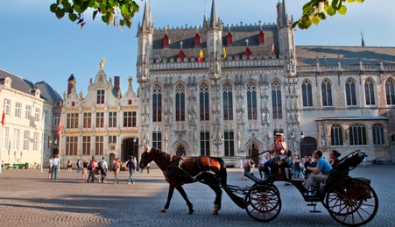](http://www.google.be/url?sa=i&rct=j&q=brugge&source=images&cd=&cad=rja&docid=8oEGp62wa6UzMM&tbnid=6KUcKIImfrkJEM:&ved=0CAUQjRw&url=http://www.hotelbrugge-oostkamp.be/&ei=VIl_Ub3rJYqa0QXZiIGwDg&bvm=bv.45645796,d.d2k&psig=AFQjCNGxUF2x-3Tpnca8I_nFw6-n4NnfvQ&ust=1367399096303691)*

***[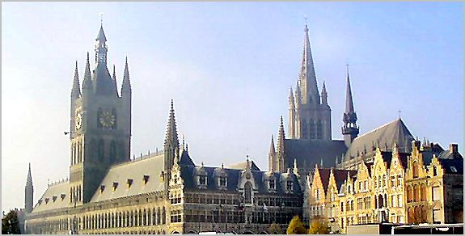](http://www.google.be/url?sa=i&rct=j&q=ieper&source=images&cd=&cad=rja&docid=3-YrcXRY2hVb2M&tbnid=N28UgqgViPQCDM:&ved=0CAUQjRw&url=http://www.trabel.com/ieper/ieper.htm&ei=XYt_UZH2NcST0AWA8YDQAg&bvm=bv.45645796,d.d2k&psig=AFQjCNEXccbKGqwmNPkpS2mwJqrxcdJ3EA&ust=1367399637362469)[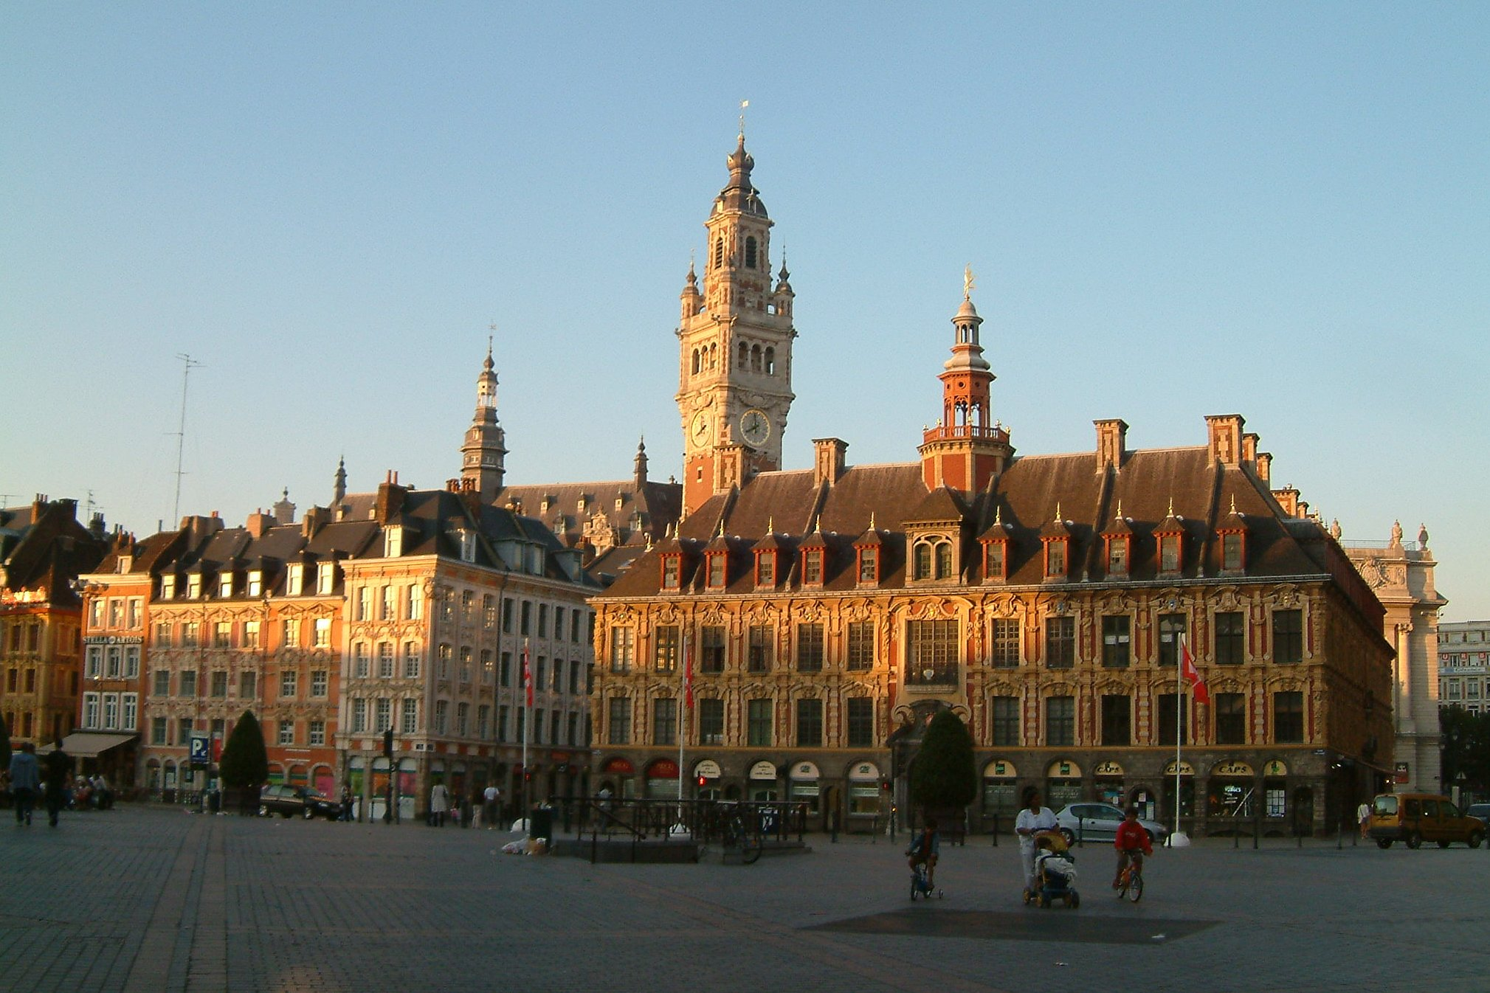](http://www.google.be/url?sa=i&rct=j&q=lille&source=images&cd=&cad=rja&docid=OZ3gHV7bYIDm2M&tbnid=FlIfaL7v50tRnM:&ved=0CAUQjRw&url=http://www.hifrance.org/auberge-de-jeunesse/lille.html&ei=4Yl_UbTzFejP0AW7-oDACg&bvm=bv.45645796,d.d2k&psig=AFQjCNFFiGzm5Aix_UtCSDno9chfx2H--A&ust=1367399255148804)[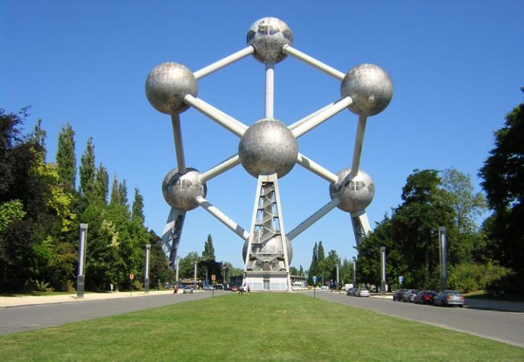](http://www.google.be/url?sa=i&rct=j&q=brussel&source=images&cd=&cad=rja&docid=yjQDP1sZj-wc_M&tbnid=nZkUDI90HMobKM:&ved=0CAUQjRw&url=http://www.gezinopvakantie.nl/2012/06/beleef-bruisend-brussel/&ei=CIt_UZT4DMGg0QWx54D4Dg&bvm=bv.45645796,d.d2k&psig=AFQjCNHV4wOm-VHVHq62M_7_2sicLbaCGQ&ust=1367399526627063)Participation costs***

Gent

Lille

Brussels

Bruges

Kortrijk

*There is* ***no participation fee*** *for teams that are lodging during the tournament.*

*Those teams only will have to pay a part of their accommodation and/or catering costs.*

*Three formulas are possible for participation in the tournament:*

1. *Formula A: with accommodation for two nights and five meals.*
2. *Formula B: without accommodation but with three meals.*
3. *Formula C: without accommodation or meals.*
4. ***Formula A (two nights at the hotel – full board)***

*This formula consists of:*

* *2 nights (27th and 28th) in one of our high level hotels, in double or triple room.*
* *Breakfast buffet on 28th and 29th.*
* *3 lunches at the tournament restaurant: 27th, 28th and 29th noon.*
* *2 suppers at the tournament restaurant: 27th and 28th evening.*
* *Water during the tournament*

***Favourable price per person: € 95, - (single room: € 135.-)***

*Maximum 14 people (12 players + coach + team manager) can benefit of this very favourable price.*

***Each additional person: € 105,- (single room: € 145,-)***

* *breakfasts and other meals are also included*

***Each additional night: € 30,- (single room: € 50,-)***

* *breakfasts included*
* *price applicable for every person in the group (also parents,....)*

1. ***Formula B (only lunches)***

*This formula consists of:*

* + *3 lunches at the tournament restaurant: 27th, 28th and 29th for 12 players, 1 coach and 1 team manager.*
  + *Water during the tournament.*

***Favourable price per team: € 320, -***

1. ***Formula C (no hotel or lunches)***

*Teams choosing this formula pay a participation fee for the team:* ***€ 120,-***

***Guarantee***

*For avoiding late forfeits, the payment of a guarantee before November 15th is mandatory. The registration will only be final when the guarantee is paid. The amount of the guarantee is:* ***€ 250.***

*In case of non notified absence of the team, the guarantee will not be reimbursed.*

***In case of notified absence, the following rules are applicable:***

* *2 months before the tournament = reimbursement 100%*
* *1 month before the tournament = reimbursement 50%*
* *Less than 30 days before the tournament = no reimbursement*

*Payment details will be forwarded to the participating clubs, immediately upon reception of the registration.*

*This guarantee is to be paid on the account below: (mentioning club name and age group)*

*ACCOUNT NAME: SPORTS AMBASSADORS*

*IBAN: BE07 6301 3050 4566*

*BIC: BBRUBEBB*

*ADDRESS: BASKETBALL PROJECTS, Kloosterstraat 2/23, B-8510 MARKE.*

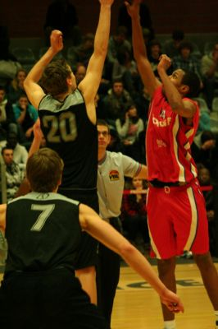

***REGISTRATION FORM***

*Name of the club:*

# *Country:*

*Registers for the 2014 Altia X-Mas Tournament in the category:*

* *Men Under 19*
* *Men Under 16*
* *Mixed Under 14 please mention “X” in the*
* *Women Under 19 chosen categories*
* *Women Under 16*

*Formula:*

* *Formula A: Accommodation 2 nights*
* *Formula B: Only lunches*
* *Formula C: No lodging or lunches*

*(Please indicate the chosen formula)*

*Please forward this document by e-mail to:* [*Peter.delepeleire@telenet.be*](mailto:Peter.delepeleire@telenet.be)

*Responsible of the club:*

*(Please mention your contact data)*